ILLINOIS MEDICAL EMERGENCY RESPONSE TEAM
PATIENT RECORD

Location:

Tracking number:

DATE: ___________ TIME: ___________ DOB: ____________ AGE: ______ M / F
NAME: ___________________________________ ADDRESS: ________________________________ CITY: _________________________ STATE: ____ ZIP: ________ PHONE: ________________________
EMERGENCY CONTACT: ________________________ RELATIONSHIP: ___________ PHONE: __________
CHIEF COMPLAINT: |  |  |  | PMH:
MEDICATION:

ALLERGIES: |  |  |  | LNMP: |  |  | WEIGHT:
VITAL SIGNS FLOW SHEET
TIME | B/P | PULSE | RESP | SPO2 | TEMP | GCS |  | Glucose
Nurse/Medic Signature____________________________________________________________________________
TIME |  | COMMENTS / TREATMENT / PROCEDURES FLOW SHEET
TIME | MEDICATION DOSE / ROUTE |  | TIME GIVEN | STAFF SIGNATURE
Physician Signature: |  |  |  |  | Date/Time:
Physician/Provider Notes Patient Name: ________________________
General Appearance: Alert______ Drowsy______ Arousable______ Other________
Pupils: PERRL______ Unequal_____ Left Side__________ Right Side__________
Neuro: A&Ox3 ________ ENT: __________
Pulmonary: Clear_______ Wheezing_______ Rales_______ Rhonchi_______ Other__________
CV: Reg. Rhythm_______ Irreg. Rhythm_______ Normal Rate_______ Tachy____ Brady_______
Abdomen: Soft, NT_______ Tenderness_________ Location__________________________________
Skin: Normal_______ Hot/Cold Diaphoretic_______ Extremities: ____________________________
Comments:

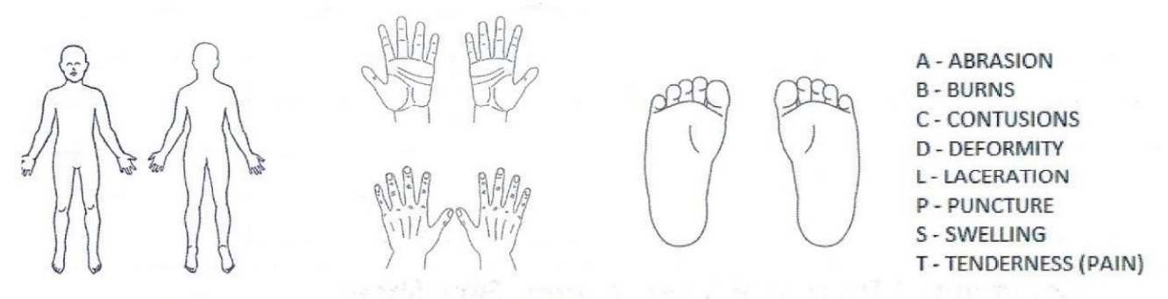
Orders/Procedures:
Physician/Provider Signature |  | DATE/TIME
Discharged by: | TRANSFERRED TO: DATE/TIME  EMS UNIT: ______________ Other: _______________
Discharge Instructions: (HOME)
PT VERBALIZED UNDERSTANDING: YES NO ACCOMPANIED BY: SELF OTHER:
PT SIGNATURE:
____________________________________________ TRACKING No. __________

